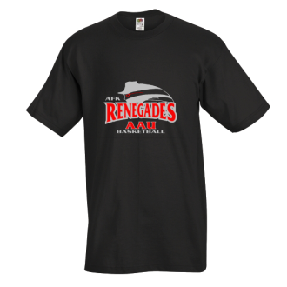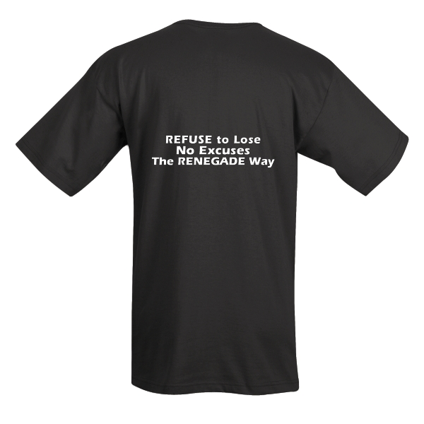
BACK
FRONT
Small | Medium | Large | X-Large
Qty: | Qty: | Qty: | Qty:
 | 2X-Large | 3X-Large
 | Qty: | Qty:
(Minimum order required)
Sizes S-XL: $12.00
Sizes 2XL-3XL: $15.00
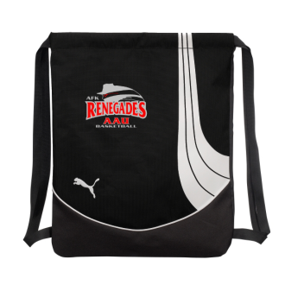
(Minimum order required)
Puma Drawstring Bag Embroidered with Renegades Logo
Qty:
Price: $22.00

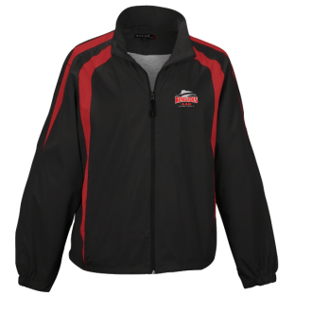
(Minimum order required)
Small | Medium | Large | X-Large
Qty: | Qty: | Qty: | Qty:
2X-Large | 3X-Large
Qty: | Qty:
Red and Black Zip Up Jacket with Renegade Logo

Sizes S-3XL: $33

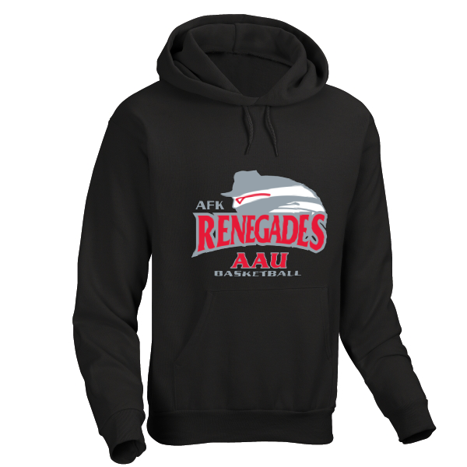
Black Pull-over Hoodie with Renegade Logo
Small | Medium | Large | X-Large
Qty: | Qty: | Qty: | Qty:
2X-Large | 3X-Large
Qty: | Qty:

Sizes S-3XL: $25

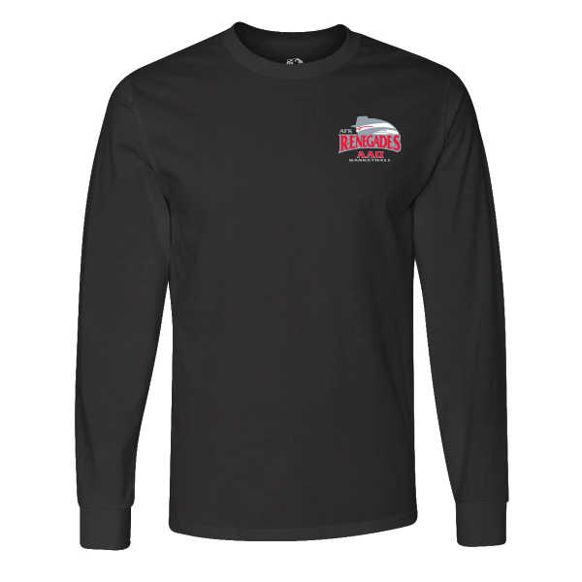
Small | Medium | Large | X-Large
Qty: | Qty: | Qty: | Qty:
2X-Large | 3X-Large
Qty: | Qty:
Black Long Sleeve Shirt with Renegade Logo

Sizes S- XL: $14
Sizes 2XL-3XL: $16

